## Compulsory task 2

Give the values of **P(B)** and **P(A and B)** in the following scenarios. You are welcome to calculate **P(A|B)** if you choose to do so:

* You work for a risk analysis insurer. You have read that this year, out of all drivers on the road, 5% have had accidents under the age of 25. You have also read that 10% of all drivers are under the age of 25. A new client approaches you and states that their age is 22. You want to calculate the chance that this driver has had an accident this year based on their age.

A = Driver had an accident this year

B = Driver is under 25 years old

P(A and B) = 5 % = 0.05 – under 25 and having an accident

P(B) = 10 % = 0.1 – being a driver under 25

So, P(A|B) – given under 25, probability of an accident

P(A|B) = P(A and B)/P(B) = 0.05 / 0.10 = 0.5 🡪 if a driver is under 25, the probability of having an accident this year is 50%.

* Your friend told you that they would buy you lunch if you can flip a coin and have it land on heads twice. You flip it the first time, and it lands on heads. What are your chances now of it landing on heads again?

A = First flip is heads – this has already happened

B = Second flip is heads

P(A) = 0.5

P(B) = 0.5

P(A and B) = 0.5 * 0.5 = 0.25

P(B|A) = P(A and B) / P(A) = 0.25 / 0.5 = 0.5

So, P(B|A) = P(B)

The chance of landing on heads again is 50 %. So basically, the result of the first flip does not affect the second flip, these events are independent of each other.

* You were always told that knowing Maths helps you to achieve 80% in Computer Science. You read some statistics showing that 30% of all Computer Science graduates took Maths and achieved 80%. Overall, 60% of all Computer Science graduates took Maths. Considering you took Maths, what are your chances of achieving 80%?

A = Achieving 80% in Computer Science

B = took maths

P(B) = 0.6 (probability of a Computer Science student having taken Maths)

P(A and B) = 0.3 (probability of taking Maths and achieving 80%)

Calculated P(A|B) = P(A and B)/P(B) = 0.3 / 0.60 = 0.5 🡪 Given that I took Maths, my chance of achieving 80% in Computer Science is 50 %.

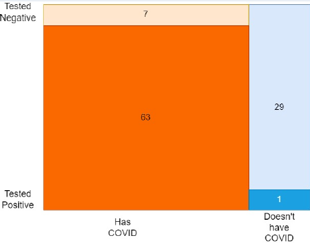

This is a mock study created using a total of 100 participants. The two orange areas show the total number of people who actually have COVID, and the two blue areas show the total number of people who don’t actually have COVID.

The two darkly-coloured areas at the bottom show the people who *tested* positive for COVID. The two lightly-coloured areas show the people who *tested* negative for COVID.

* Using this diagram, and information learned from the video, state the following:
  + **H**: our hypothesis – people who actually have COVID
  + **E**: our evidence – people tested positive for COVID
* Then, give the values for the following:
  + **P(H) =** people who actually have COVID/Total participants = (63+7) / 100 = 0.7 🡪 this is called prior probability
  + **P(E|H) =** people who tested positive and have COVID / Total people who have COVID = 63/70 = 0.9 🡪 this is called likelihood
  + **P(E) =** total people who tested positive / Total participants = 64 / 100 = 0.64 🡪 this is called marginal probability
  + **P(H|E) =** probability that a person actually has COVID given they tested positive

P(H|E) = P(E|H)P(H)/P(E) = (0.9 * 0.7) / 0.64 = 0.98

If a person tests positive, there is a 98% chance that he/she actually has COVID. This suggests a highly accurate test, with very few false positives. However, 10% (7 out of 70) of COVID-positive individuals received a false negative result.